How the entire process works from the Local level Listers and Treasurers to the State level the Tax Department and Education Department. In a typical year Municipalities will make adjustments to their Grand List and send tax bills. These bills include Muncipal Taxes and Education taxes. This document explains how this process works and who is getting your data and using the numbers that have been submitted by your Municipality.

Here is the flow of data.
Local Level As Billed Grand List

Send Grand List to PVR on Aug 15th

Ed Dept Receives Data and Calculates Ed Taxes to be raised by Town at this point.
PVR Processes data

Continue editing As Billed Grand List as needed until December 30th

Send Final Grand List to PVR between Jan 1st - 15th

PVR Processes data

Ed Dept Receives Data and calculates final Ed Taxes sending final Cash Flow Statement to the Town.
PVR Sends Letter to Town Clerk to confirm numbers are accurate

Yes
No

SENDING FILES

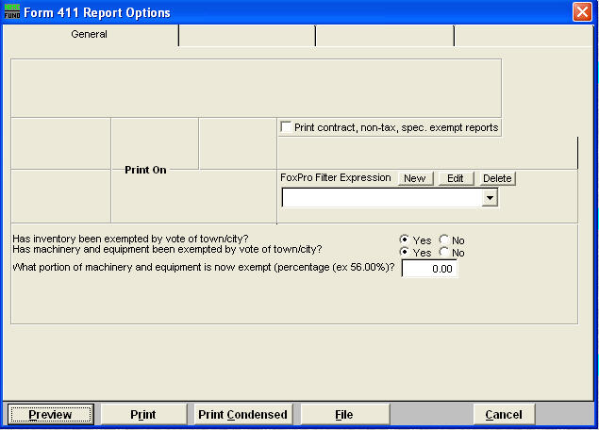
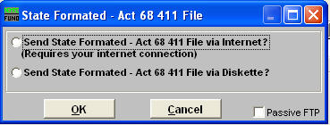
- Select (‘4’ Form 411) on the report menu.
- Choose the appropriate options for running this report. Then Print or Preview it on the screen.

3. Select ‘Send via Internet when prompted

The files created and sent to PVR are also stored in your NEMRC Directory. They are as follows:

- 411EXP##.CSV – List of Totals of Exemptions in your Grand List. IE: Veterans, Contract, Farm Stabilization, Current Use, and Special Exemptions.

- 411LST##.CSV – List of all your parcels where Tax Status is Non Taxable and State Owned Land

- 411TFP##.CSV – Shows all parcels within your TIF District regardless of Parcel Status or Tax Status.

- 411TFS##.CSV – TIF Summary File, This shows the information displayed on the ‘Installation’ ‘TIF Setup’ tab

- 411TOT##.CSV –Shows your 411 Totals for Listed values, and Grand List totals. Also shows TIF district showing the information displayed on the ‘Installation’ ‘TIF Setup’ tab

- 411_GL##.CSV – All parcels on your Grand List report.

Final 411 report
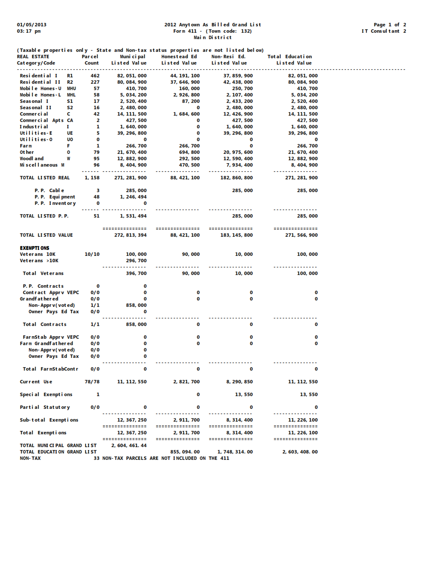

PVR Processes Data – Below is a copy of the letter that is sent from PVR to your Municipality. Once received by the Clerk it should be shared with the appropriate personnel. Confirm the “Homestead” and “Non Residential” Education property values seen on this sheet matches your 411 report. Page 3 of this document. These are the numbers that will be submitted to the Education Department. They will use these numbers to calculate your Municipalities total education taxes. If it is not correct contact PVR promptly and resend the correct file to them.
IT IS IMPORTANT TO DO THIS BEFORE YOUR DATA IS SENT TO THE EDUCTATION DEPARTMENT FOR PROCESSING.
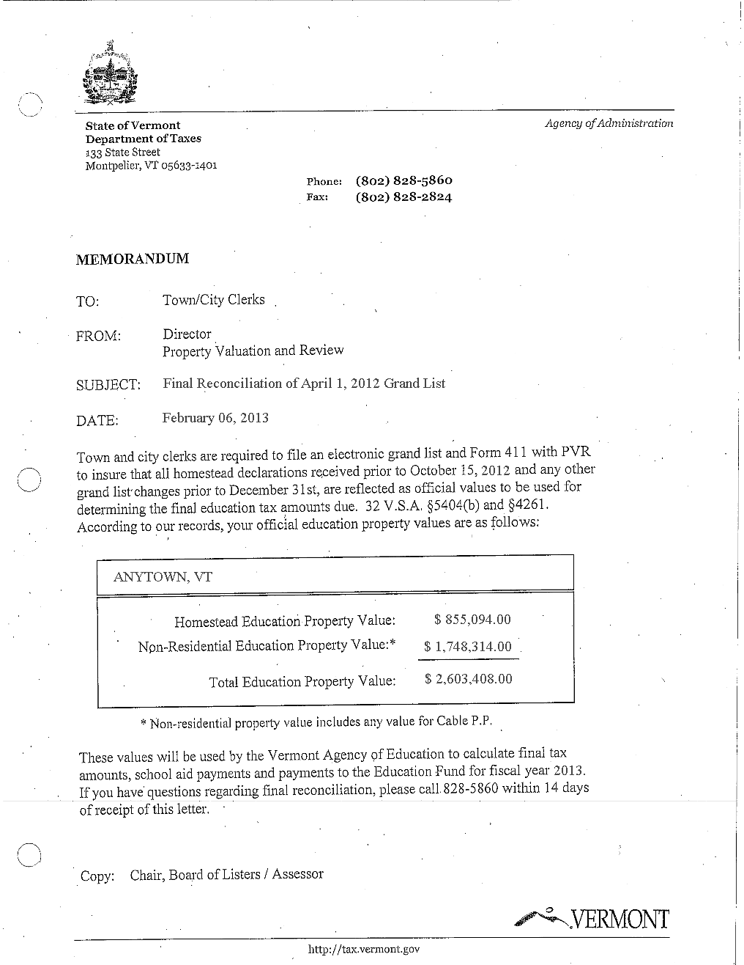

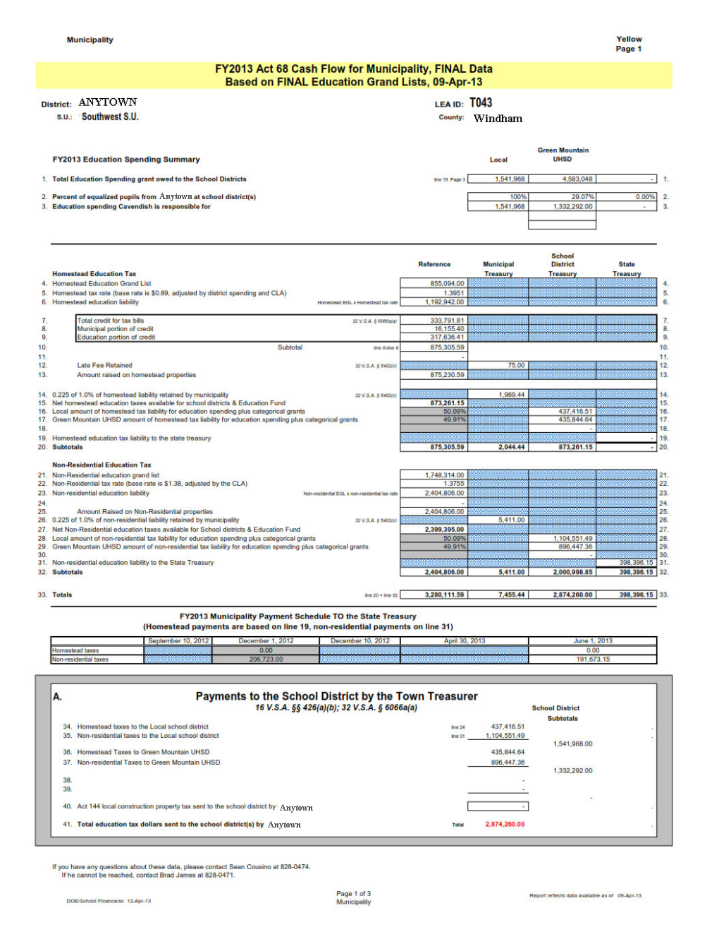
Education Department Cash Flow Statement

Education Department Cash Flow Statement Continued

Key to the Numbers on the Cash Flow Statement

1 – 3. These are your Education Spending numbers
4. Homestead Education Grand List – This comes from your 411 report look at the Homestead Grand List column. Refer to page 3 of this document.
5. Homestead tax rate – Your Towns Homestead Education Tax rate that was used for producing tax bills. Refer to your Tax book summary page, using option ‘5 Tax Book’ on the ‘Reports Menu’. See page 7 of this document.
6. Homestead Education Liability – This is your Homestead taxes + Non approved Contracts and Veterans exemptions with homestead declarations declared. AKA(Local Agreement Taxes). Refer to your tax book on page 7 and find the Local Agreement tax. Then you need to find out how much of that tax should be applied to Homestead Edu Tax rate. Look at page 2 of the 411 report on the botton of page 7. Find all Homestead Non Approved Contracts/Exemptions & Homestead Veterans Exemptions beyond 10k. Add them together and multiply times .01 then by your Homestead Ed Rate.
7. – 9. Total credit for tax bills – This is the total of all the state payments being applied to the tax bills. Refer to your ‘8. Homestead Payment Reports’ found on the Main Menu of your As billed grand list. See illustration on page 8 of this document. This example shows that this town has 2 state payment download files. You must add the totals together from these reports to match #7 on the Cash Flow Statement.
10. Subtotal – Line 6 minus Line 9 (1,192,942.00 – 317,636.41) = 875,305.59.
11. N/A – in this example
12. Late Fee Retained – This is the amount of money the Municipality gets to keep because someone filed their Homestead Payment late. The Municipality keeps 15.00 for each late filed HI 144. Refer to your ‘8 Homestead Payment Reports’. See Page 8 of this document.
13. Amount raised on Homestead Properties – Line 12 subtracted from line 10. Simply subtracting (875,305.59 - 75.00)=873,201.15 of the State Payment that the Municipality gets to keep.
14. 0.225 of 1% of homestead liability retained by municipality – ((Line 12 + Line 13) x 0.225) x .01 (75.00+875,230.59) x 0.225) = 196,943.76 x .01 = 1,969.44
15. Net homestead education taxes available for school districts & Education fund – (Line 13 - Line 14) (875,230.59 – 1,969.44) = 873,261.15
16 – 17. Apply percentage listed in these lines to line 15 – (Line 15 x Line 16) (873,261.15 x 50.09%) = 437,416.51 and (Line 15 x Line 17) (873,261.15 x 49.91%) = 435,844.64
18 – 19. N/A – in this example
20. Subtotals – The first column is from Line 10 which is the total Homestead Ed tax to be raised by the Municipality. The second column is Line 12 plus line 14 (75.00 + 1,969.44) = 2,044.44. The money the Municipality will keep. The third column is simply the first column minus the second column (875,305.59 – 2,044.44) = 873,261.15.
Non Residential Education Tax - Same definitions as above only using the Non Residential values
21. Non Residential Education Grand List – This comes from your 411 report look at the Non Residential Grand List column. Refer to page 3 of this document.
22. Non Residential Education tax rate - Your Towns Non Residential Education Tax rate that was used for producing tax bills. Refer to your Tax book summary page, using option ‘5 Tax Book’ on the ‘Reports Menu’. See page 7 of this document.
23. Non Residential Education Liability – This is your Non Residential taxes + Non approved Contracts and Veterans exemptions that DO NOT have homestead declarations declared. AKA(Local Agreement Taxes). Refer to your tax book. Follow the same instructions above in item 6 for calculating Homestead tax for the Local agreement only use the Non Residential Contracts/Exempts, and Non Residential Veterans exemptions beyond 10k.
24 – 27. Refer to same fields for Homestead section as they are calculated the same way.
28 -31. These 3 totals in the 3rd and 4th columns will equal the calculated 50.09% and 49.91%
32. Subtotals of this section
33. Subtotals of line 20 + Line 32
34 – 37. These numbers come from Lines 16, 28, 17, and 29
38 – 40. N/A in this example
41. Total education tax dollars sent to the school district(s) by Anytown – Subtotal of lines 34 – 40
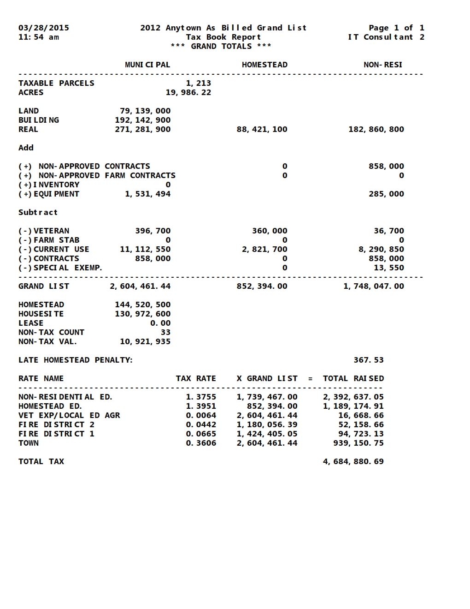

Tax Book Summary

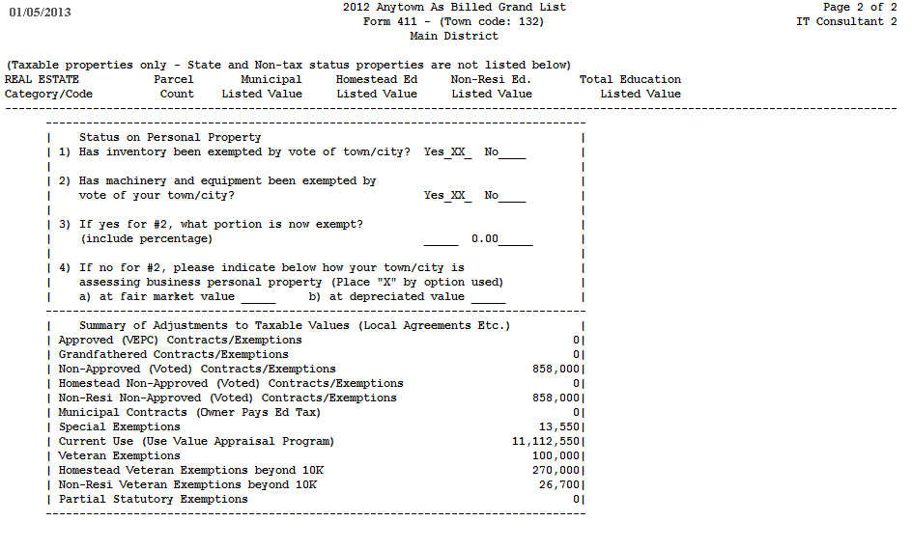

411 Report Page 2

Homestead Payment Reports – In this example you can see there are 2 files listed in the drop down window. You must use the totals from both of these reports in order to match item # 7 on the Cash Flow Statement. Some Municipalities may have more files. If so then you must use the totals from each file and add the totals together.
